ANNOUNCING: Scholarship for Disadvantaged Students (SDS)

WHO: New Family Nurse Practitioner (FNP) and Adult-Gerontology Primary Care Nurse Practitioner (AGPCNP) full-time students who enter in the fall term.

Additional Eligibility Criteria:

- Earned BSN degree

- “U.S. citizen or non-citizen national, or foreign national with permanent residence in the United States. ** Individuals on temporary student visas are not eligible under this funding opportunity.”

- SDS recipients must maintain their current enrollment status.

- Student must be from a disadvantaged background and/or has a financial need for a scholarship as defined below.

WHAT: $30,000 tuition support for full-time students (TUITION ONLY)

PURPOSE: To promote diversity among the health professions and nursing workforce.

PROCESS: Complete the SDS Fall 2017 Application and submit via NursingCAS by Saturday, April 1, 2017. This application includes a 1-2 page typed personal statement discussing (a) why would you benefit from this scholarship and (b) your interest in providing primary care and how you will use your MSN education to deliver high quality, culturally sensitive primary care immediately following graduation.

For more information or for questions, contact Johis Ortega at j.ortega10@miami.edu.

DEFINITIONS

Disadvantaged background: means an individual comes from an educationally/environmentally or economically disadvantaged background.

Educationally/environmentally disadvantaged: means an individual comes from an environment that has inhibited the individual from obtaining the knowledge, skills, and abilities required to enroll in and graduate from a health professions school, or from a program providing education or training in an allied health profession.

Economically/environmentally disadvantaged: means an individual comes from a family with an annual income below a level based on low-income thresholds (see below), according to family size established by the U.S. Census Bureau, adjusted annually for changes in the Consumer Price Index, and adjusted by the Secretary of the U.S. Department of Health and Human Services (HHS), for use in all health professions programs. The Secretary updates these income levels in the Federal Register annually

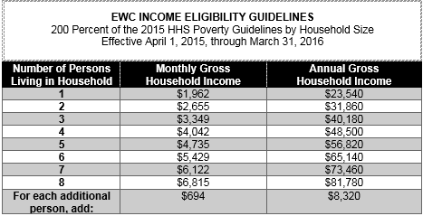

Low income family/household: is defined by the Secretary for various health professions programs included in Titles III, VII and VIII of the Public Health Service Act, as having an annual income that does not exceed 200 percent of the Department’s poverty guidelines (see below). A family is a group of two or more individuals related by birth, marriage, or adoption who live together. A household may be only one person.

